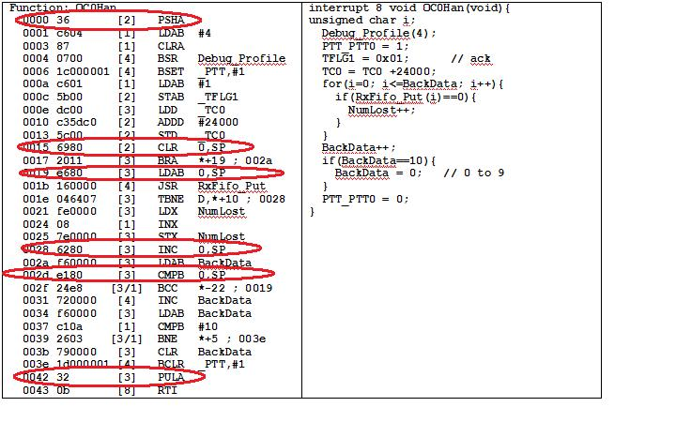

PTT_PTT0=1 takes 4 cycles.